Ürün | Adet | Mf | Fiyat | Genel toplam
DEGRA 100*4 TB | 15 | 0 | 87,06 | 1.306
DEGRA 50*4 TB | 10 | 0 | 72,99 | 730
FENISTIL 30 GR JEL-01/2016 MİAD | 50 | 0 | 6,85 | 343
GEBELIK TESTI PELY | 150 | 0 | 4,80 | 719
YAKI KURTPLAST | 100 | 0 | 3,60 | 360
JOHNSON BABY SAMPUAN 200 ML | 72 | 0 | 3,80 | 274
GASTRODEX 30*28 TB-11/2015 MİAD | 0 | 10 | 0,00 | 0
 |  |  |  | 3.731
SAMSUNG GALAXY S6 32 GB KAMPANYASI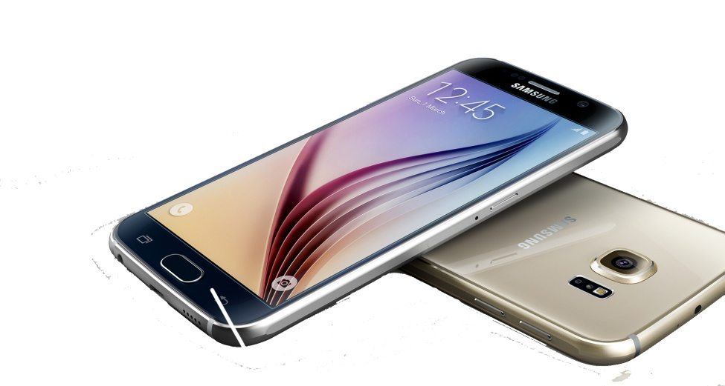
İRTİBAT TEL :
MUSTAFA KILIÇ : 0507 765 2418
İLYAS BULUT : 0554 557 7763
HALUK BİŞAR : 0543 574 5960
LEVENT SEZER : 05554 857 0502
Orjin Ecza Deposu
NOT : Hediye teslim edildikten sonra ödeme tahsil edilir.
Ekran Boyutu: 5.1", Dahili Hafıza: 32 GB, Kamera: 16 MP, İşletim Sistemi: Android, Akıllı Telefon, 3G, Wi-Fi, GPS, Bluetooth, Dokunmatik, 3G Görüntülü Konuşma

